To use the Degree of Saturation over Phase Timing Analysis feature:

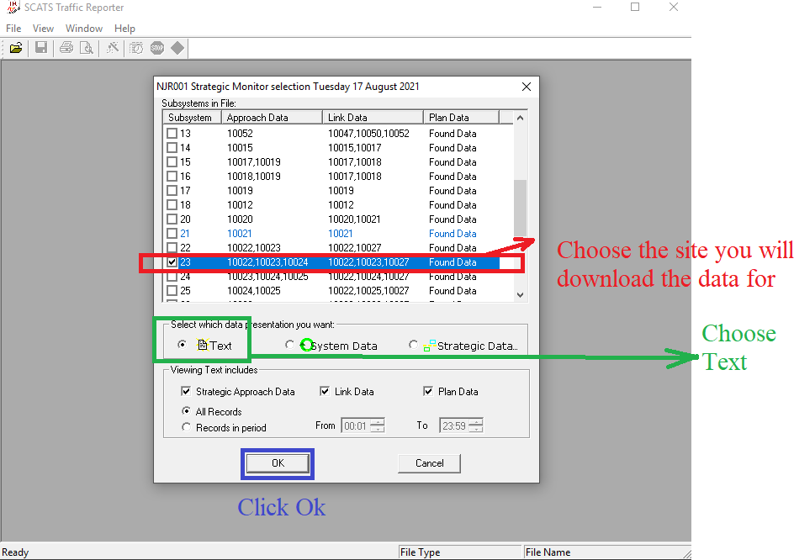**Step1:** From Traffic Reporter Choose the following options for each site you want to analyze as shown in the figure below:

**Step2:** A window will show up as shown in the figure below. Choose the date you want to analyze. Click save and save the file on your device.

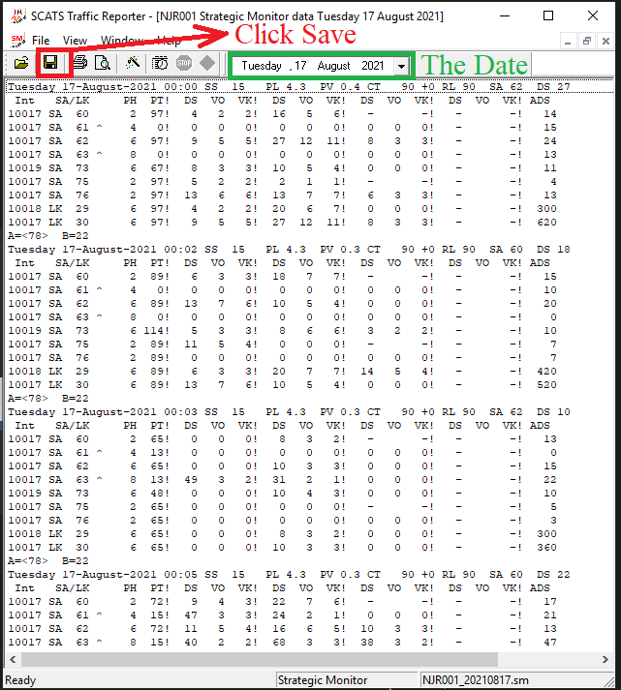

**Step 3:** Go to the following website [Link](https://abdullahshabarek.shinyapps.io/SCATS_NJDOT_AMC/), and Go to the Tab called “Degree of Saturation over Phase Timing Analysis”, and choose the file you downloaded. Choose the Route you are analyzing from the dropdown menu. Click Previous to Click Preview to see the plot of (DS over Phase timing) Vs. (Time) for the all phases in the selected intersection. Click download to download the data to your device, as shown in the figure below:

